Task 21: Encryption in the cloud overview symmetric and Asymetric

1. Write a short note explaining the difference between symmetric and asymmetric encryption, and give one real-world example of where each might be used in a cloud app like WhatsApp or Paytm
Ans: Encryption
Symmetric Encryption | Asymmetric Encryption
Uses one secret key for encryption and decryption. | Uses two keys: Public Key and Private Key.
Faster because only one key is used. | Slower because of complex mathematics.
Suitable for encrypting large amounts of data. | Suitable for secure key exchange and authentication.
Real-world Examples
Symmetric Encryption
Example: WhatsApp encrypts message content using AES-256 after securely exchanging keys.
Reason:
- Fast
- Efficient
- Good for large data
Asymmetric Encryption
Example: Paytm uses RSA or ECC during secure HTTPS connections to exchange encryption keys between the user's phone and the server.
Reason:
- Secure key exchange
- Digital certificates
- Authentication

2. Compare server-side encryption and client-side encryption by listing 3 pros and 3 cons for each method in the context of storing user photos on a cloud platform like Instagram.
Ans: Server-Side Encryption
Advantages
- Very easy to use
- AWS manages encryption
- Minimal performance impact on user device
Disadvantages
- AWS handles encryption keys
- Less control over security
- Client-Side Encryption
Advantages
1.Data is encrypted before upload
2. Full control over keys
3. Better privacy

Disadvantages
1. More complex implementation
2. User must safely manage keys
3. Losing the key means losing the data

Instagram Example
Server-side encryption:
- Instagram uploads your image normally.
- AWS encrypts it after upload.
Client-side encryption:
- Your phone encrypts the image first.
- AWS only stores encrypted data.

3. Set up an AWS S3 bucket (or use any cloud storage emulator like MinIO if you don't have an AWS account) and enable server-side encryption using AES-256 for all uploaded files. Upload a sample file and verify encryption is active.
Ans:
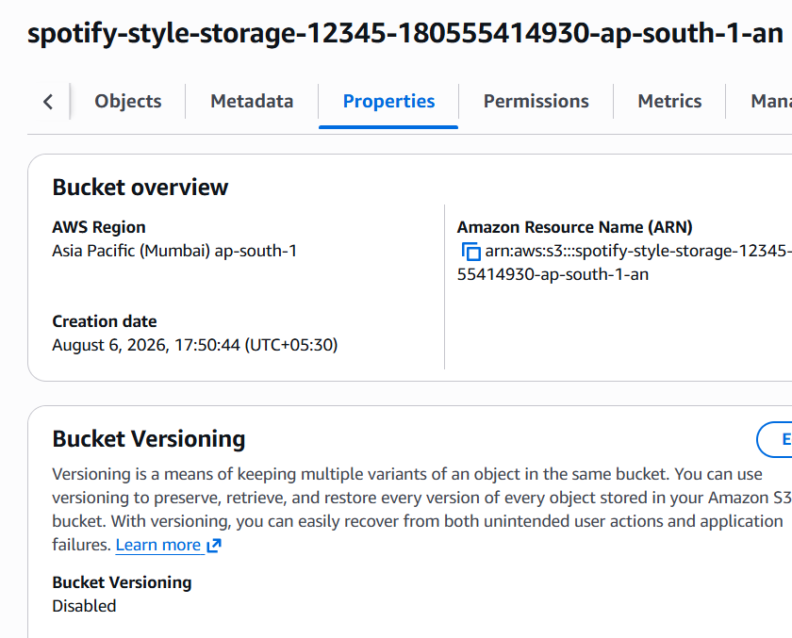
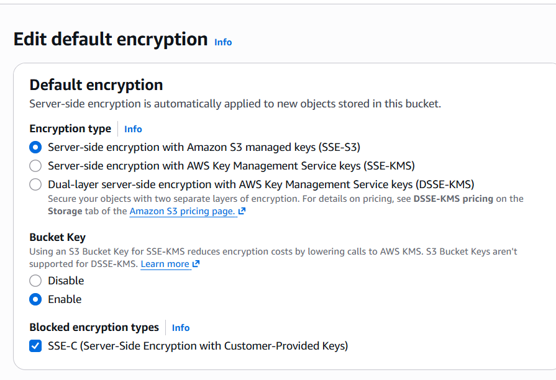
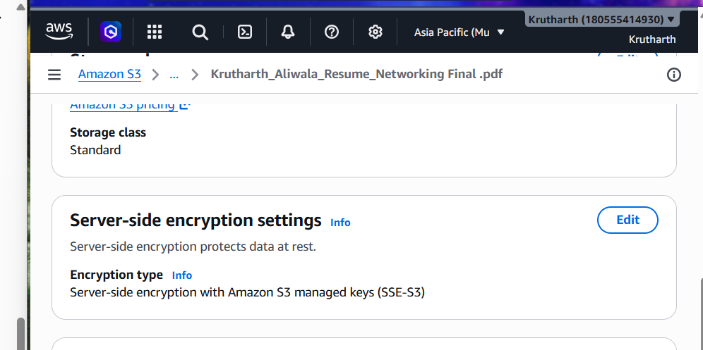
4. Simulate uploading a playlist cover image to your 'Spotify-style' S3 bucket with server-side encryption enabled, then use the AWS CLI or MinIO client to confirm the encryption status of the uploaded object.<br><br><em><strong>Hint:</strong> Use the 'aws s3api head-object' command or MinIO's object info command to check encryption metadata.</em>
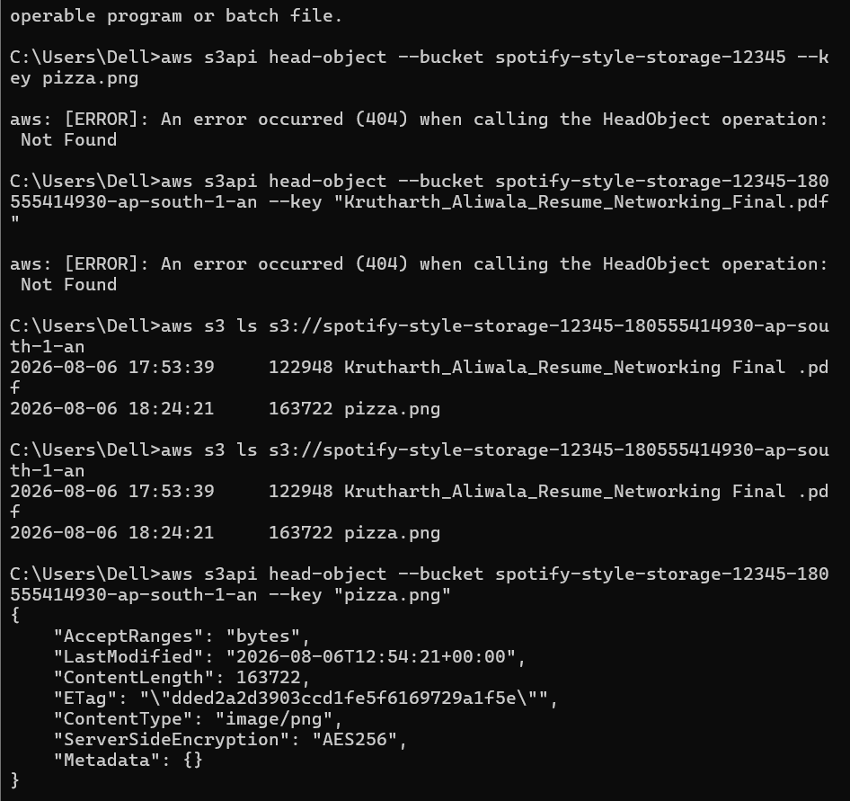

5. Use ChatGPT or Copilot to generate a code snippet in Python or Node.js that uploads a file to an S3 bucket with server-side encryption enabled. Test the code with your own file and explain how the encryption parameter works.
